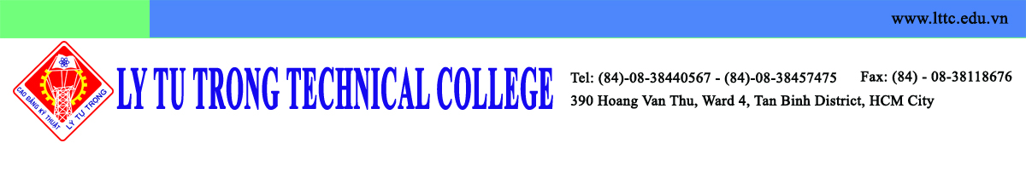

Dear Dr. Seman PYO, Director of Institute of IALE,

First and formost, I would like to respectfully wish you a merry Mid-Autumn Festival as it is coming soon. It is my great honour to be welcomed at Kunsan National University this December. In response to your inquiry into the delegation list, I hereby inform you so that it could be more convenient for your arrangement:

1. Mr. Pham Ngoc Thanh, Vice Director of Department of Education and Training of Ho Chi Minh City
2. Mr. Pham Huu Loc, Rector of Ly Tu Trong Technical College Ho Chi Minh City
3. Ms. Nguyen Ngoc Trang, Dean of Sciencetific Management and International Cooperation Office – Ly Tu Trong Technical College Ho Chi Minh City
4. Mr. Do Cong Thanh, Official of Ly Tu Trong Training Center
5. Mr. Nguyen Phu Thuong Luu, Lecturer

On behalf of Ly Tu Trong Technical College Ho Chi Minh City, I thank you for all of your help thus far in planning this delegation. We look forward to continuing to cooperate with you to make valuable contributions to the technical education in both schools and the students could get great benefit from this cooperation.

Best regards,

Pham Huu Loc
Rector
Ly Tu Trong Technical College Ho Chi Minh City

